**Introduction to MLOPS**

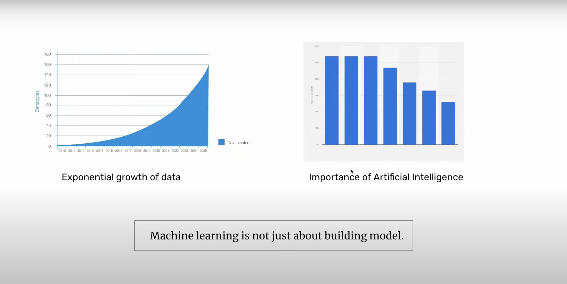

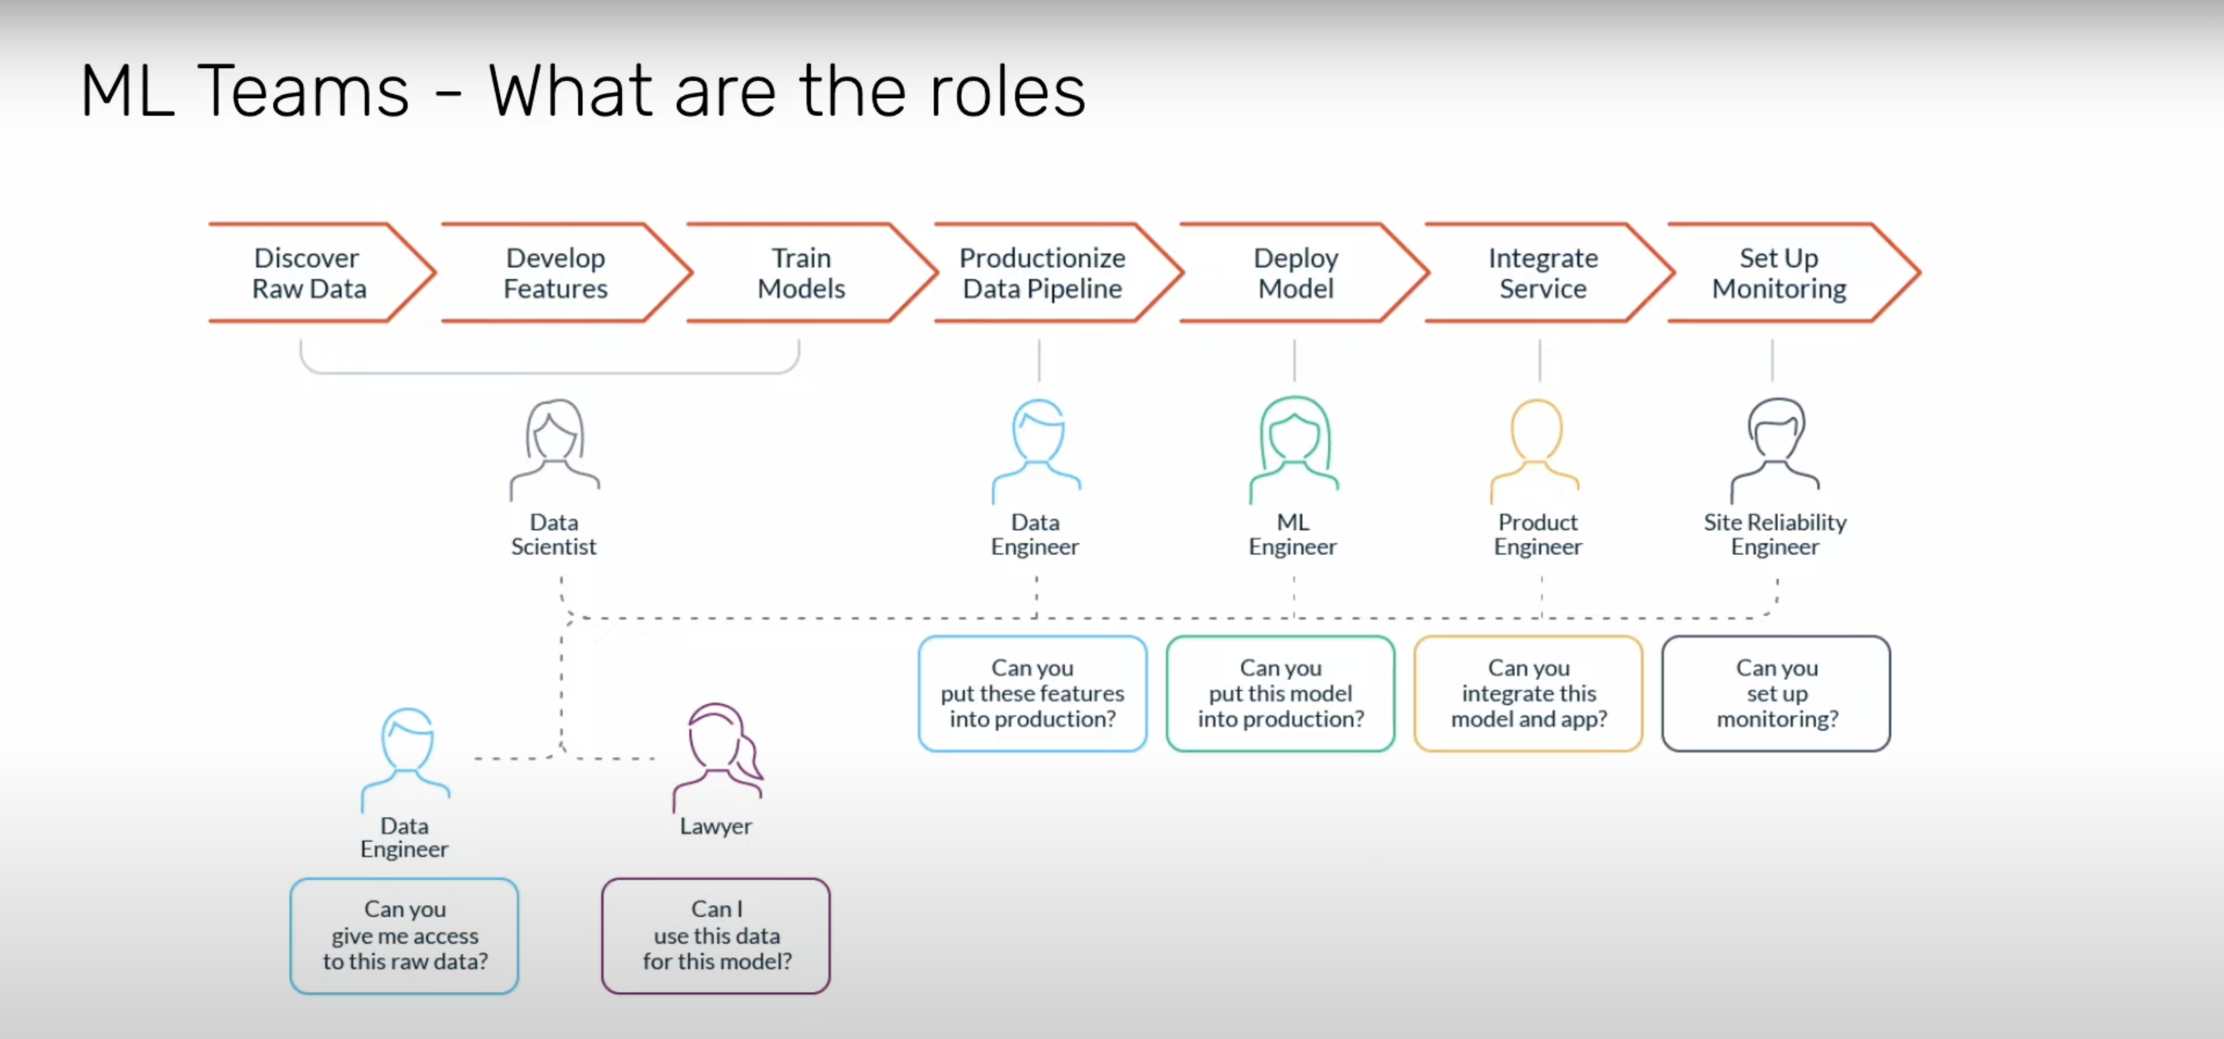

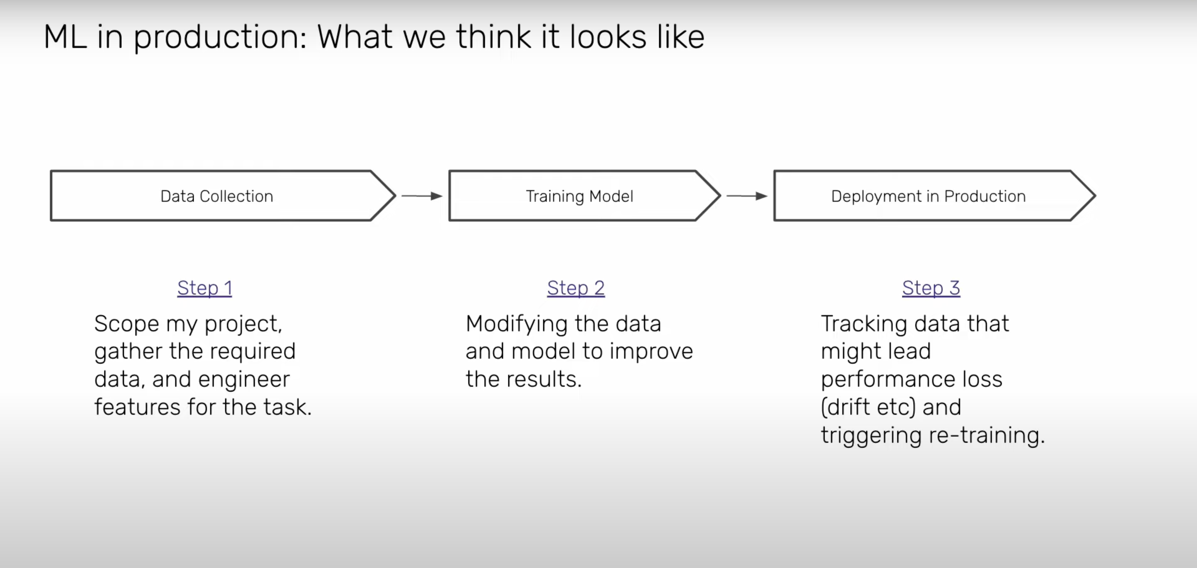

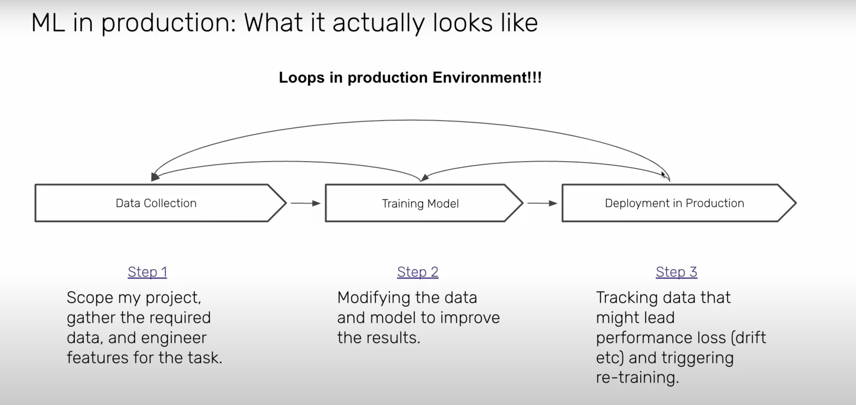

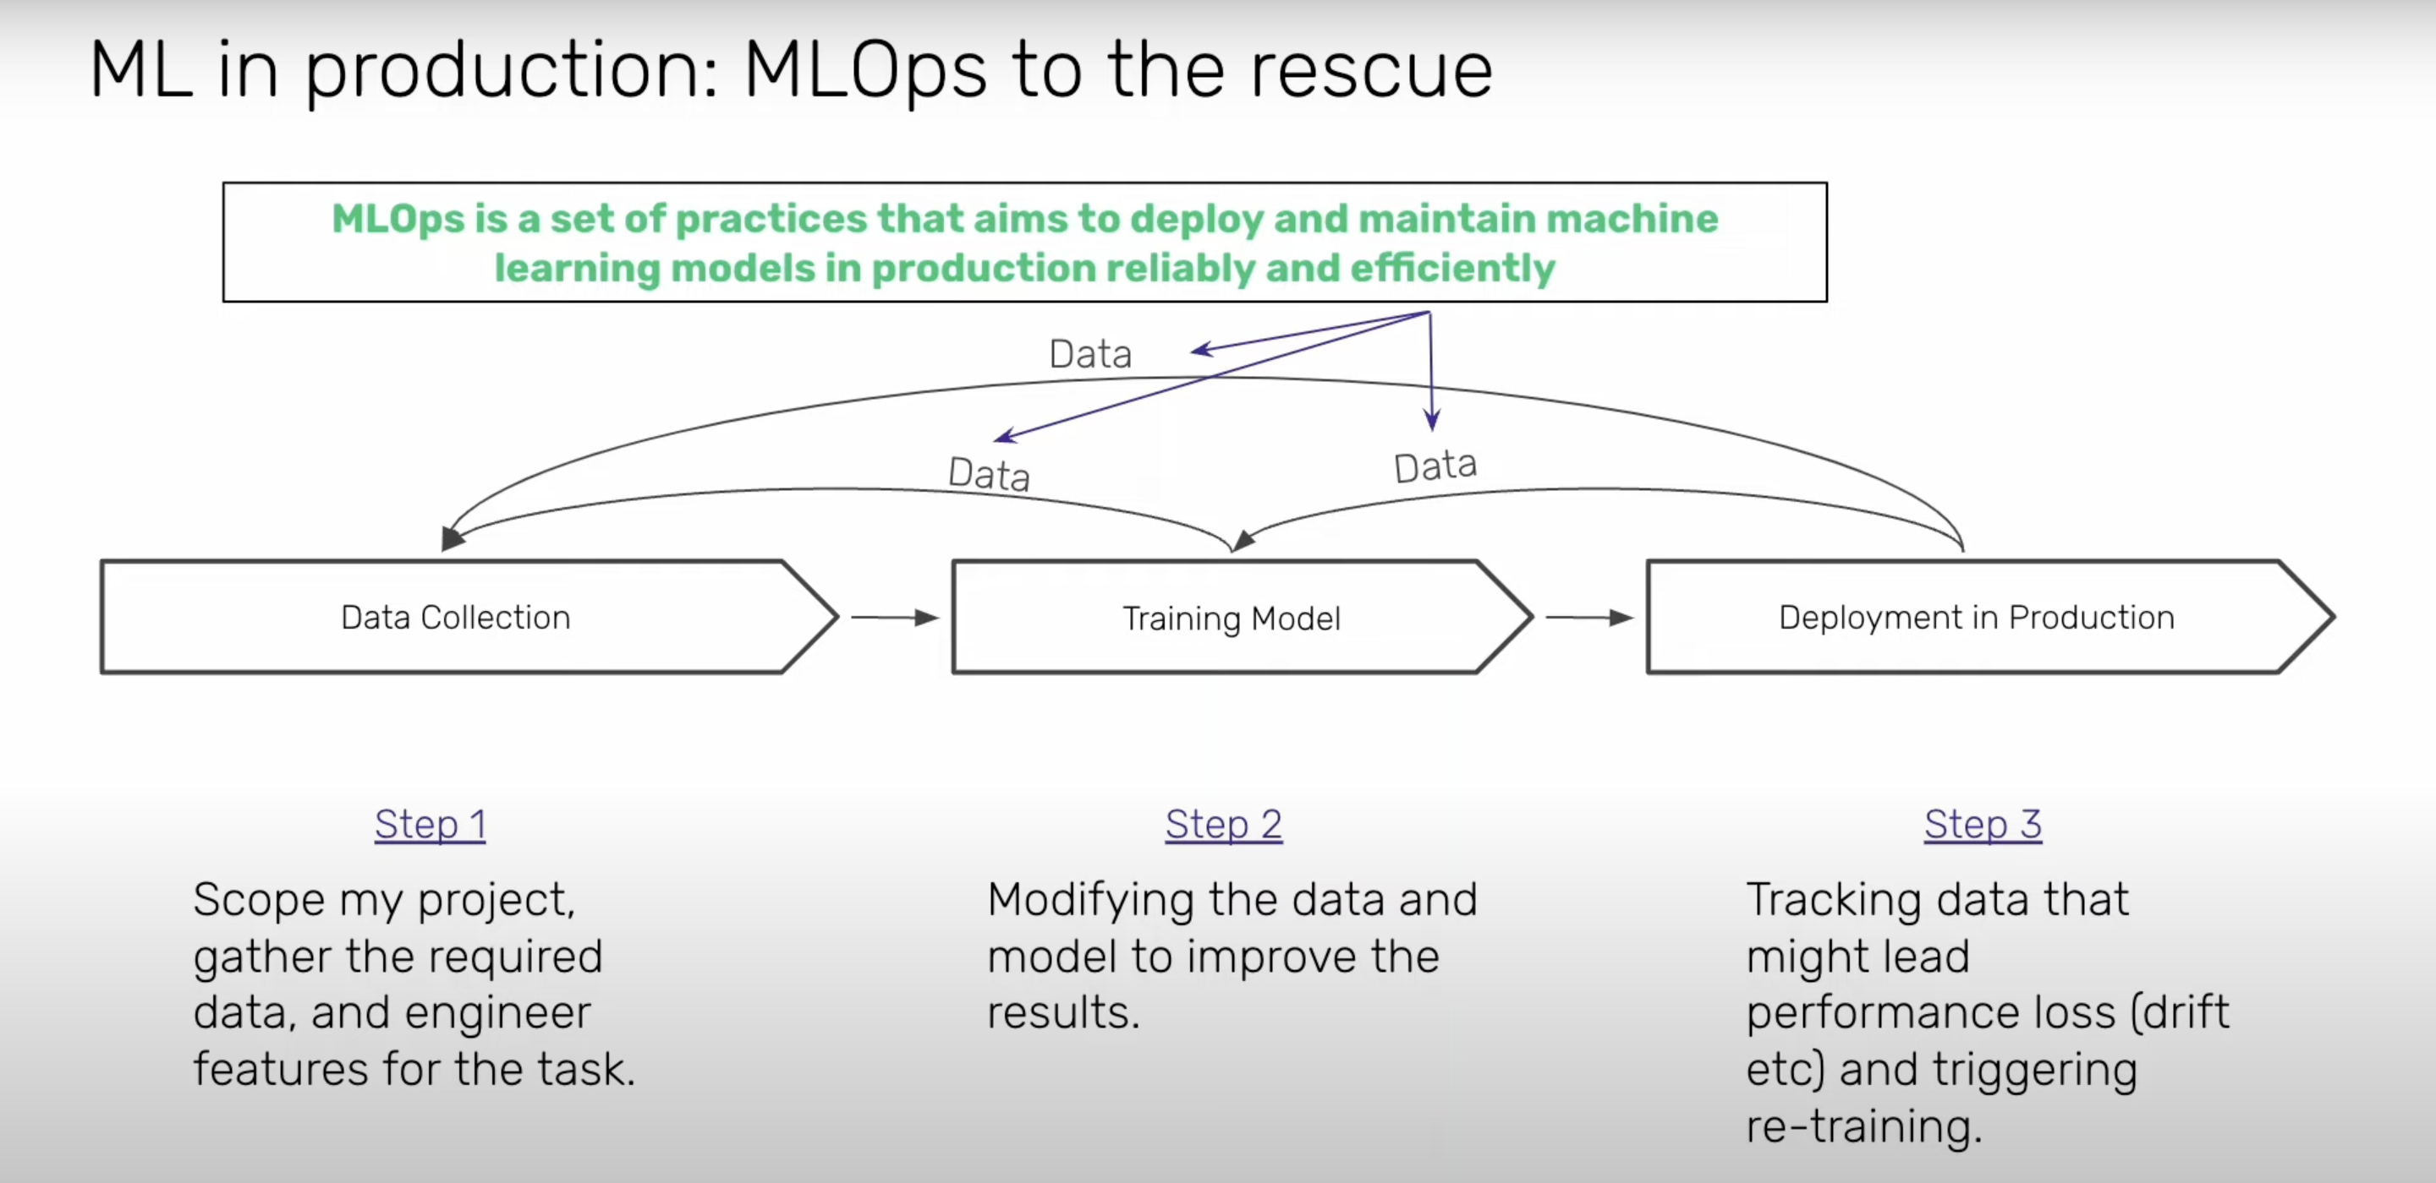



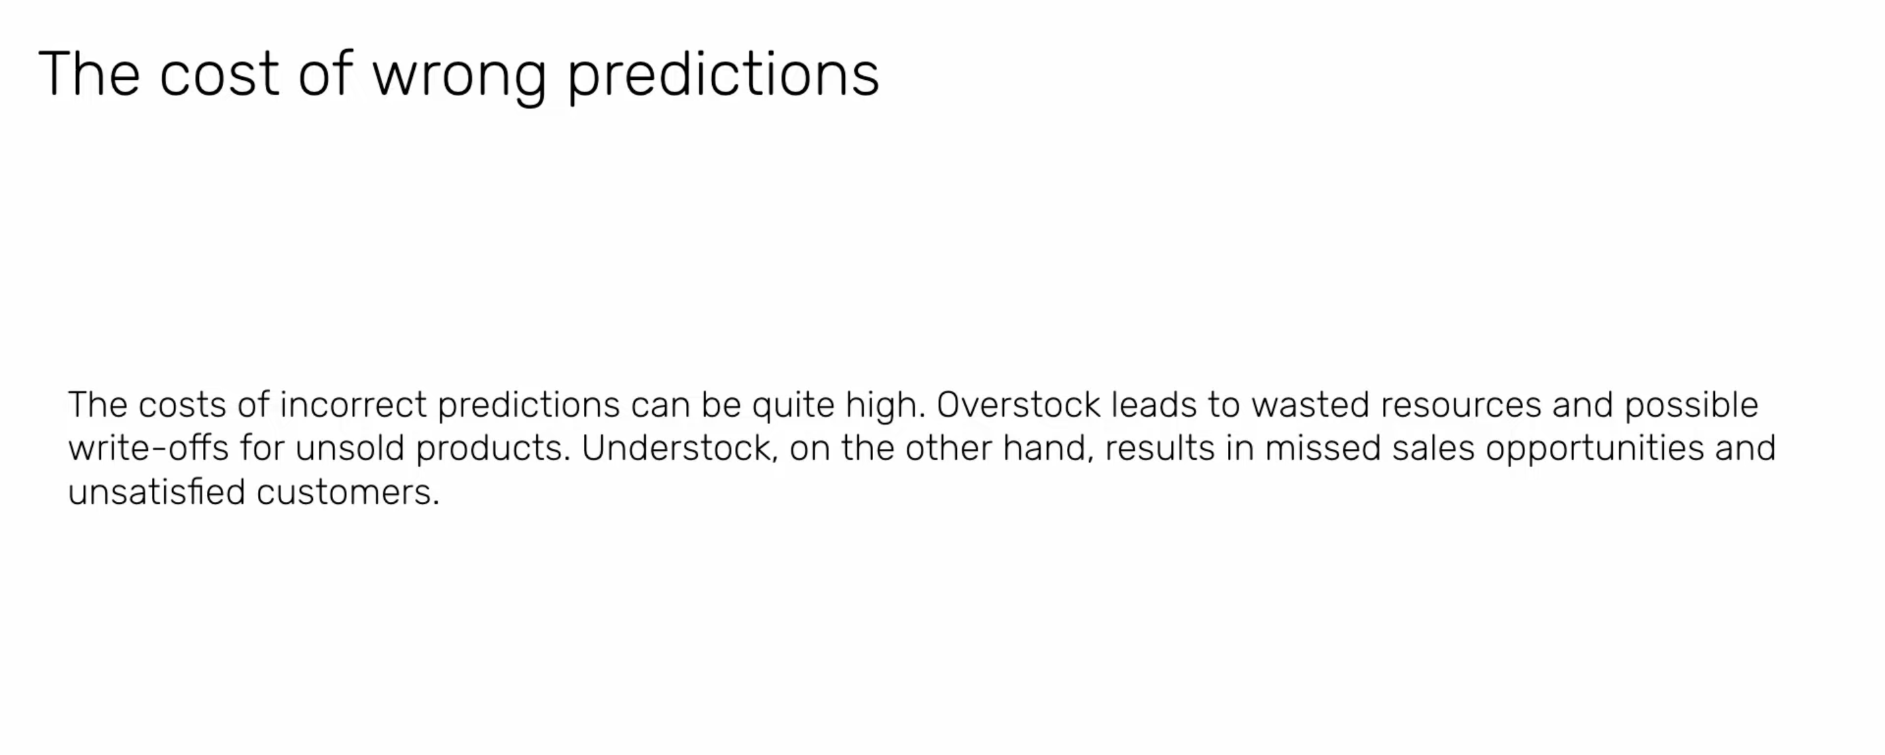

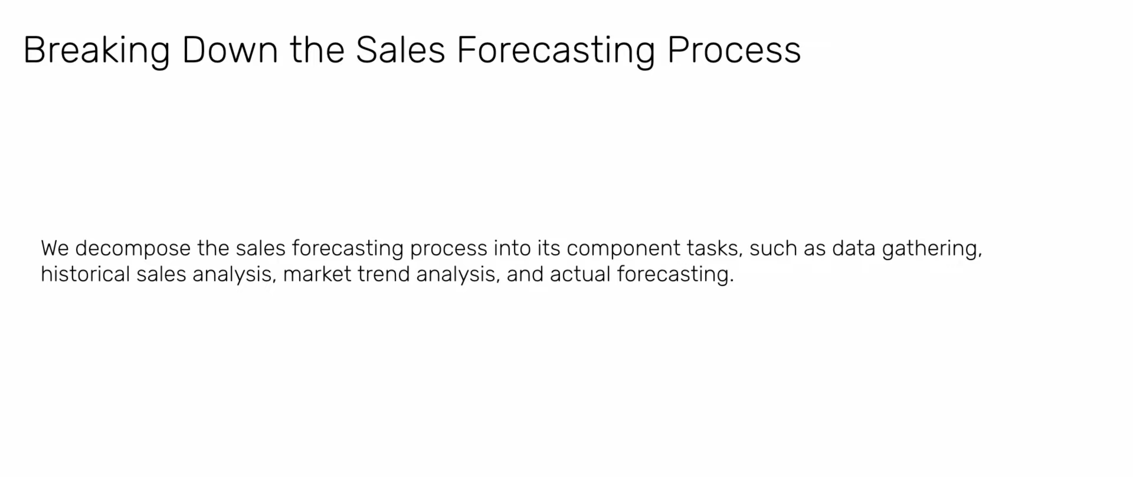

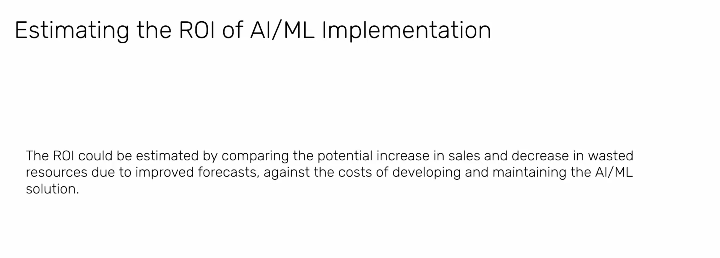

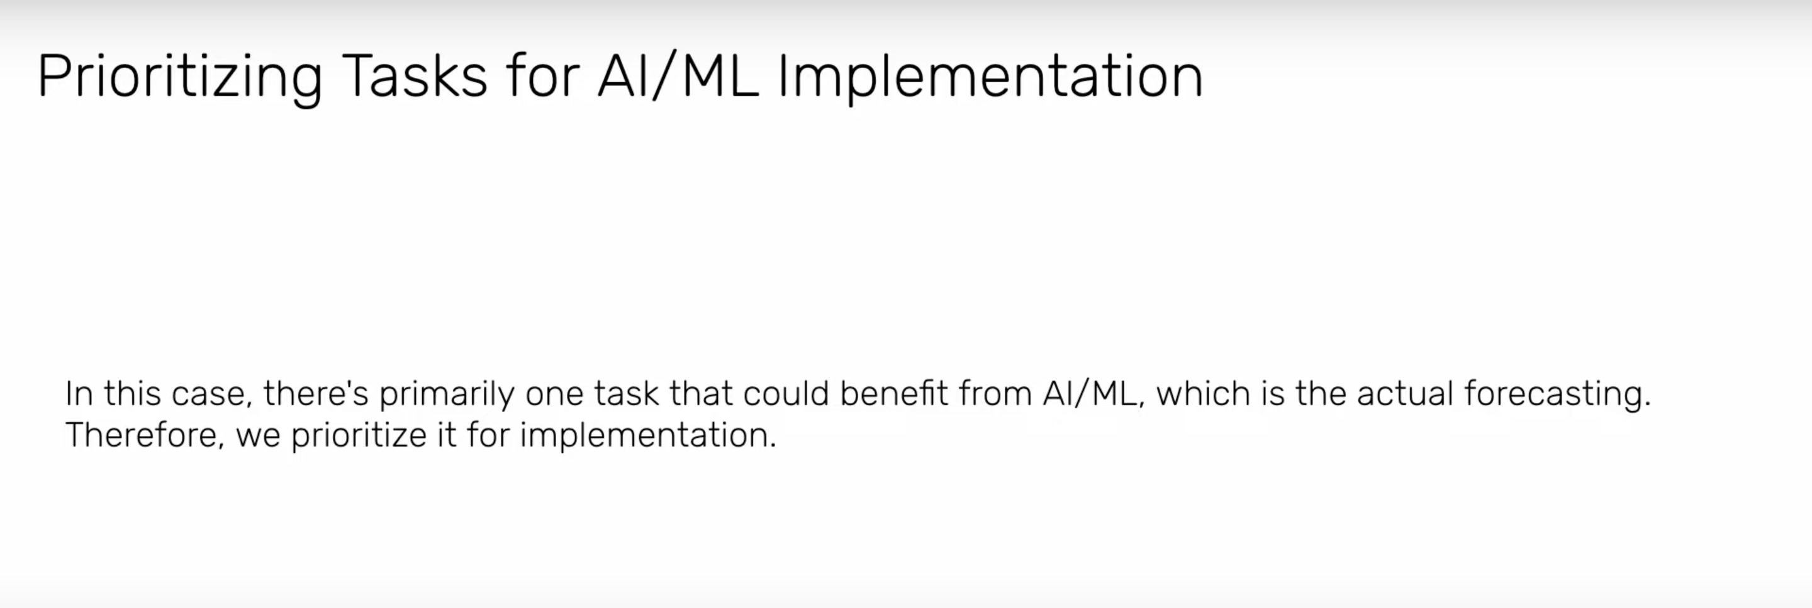

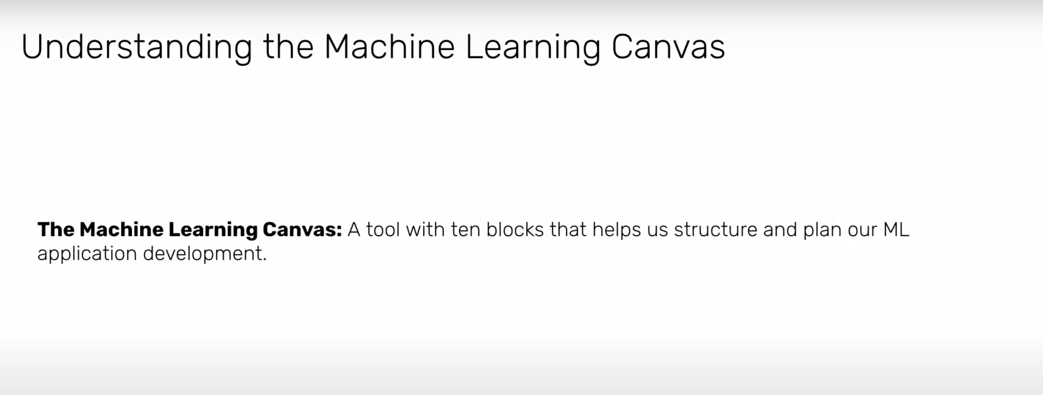

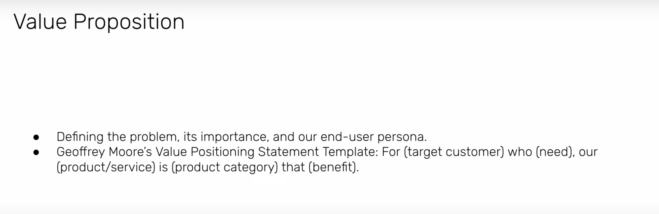

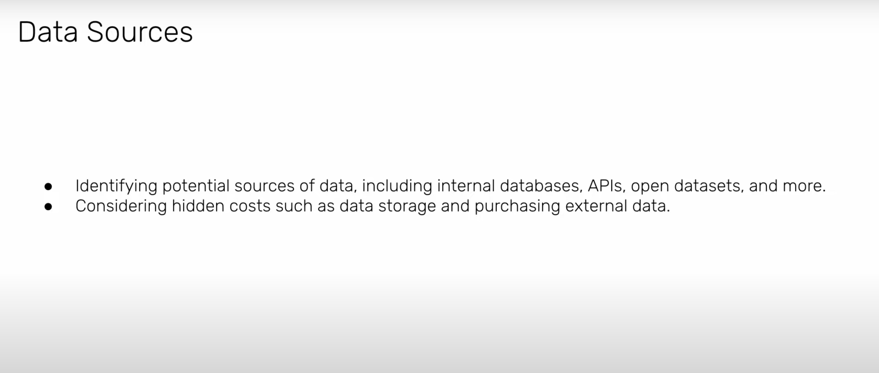

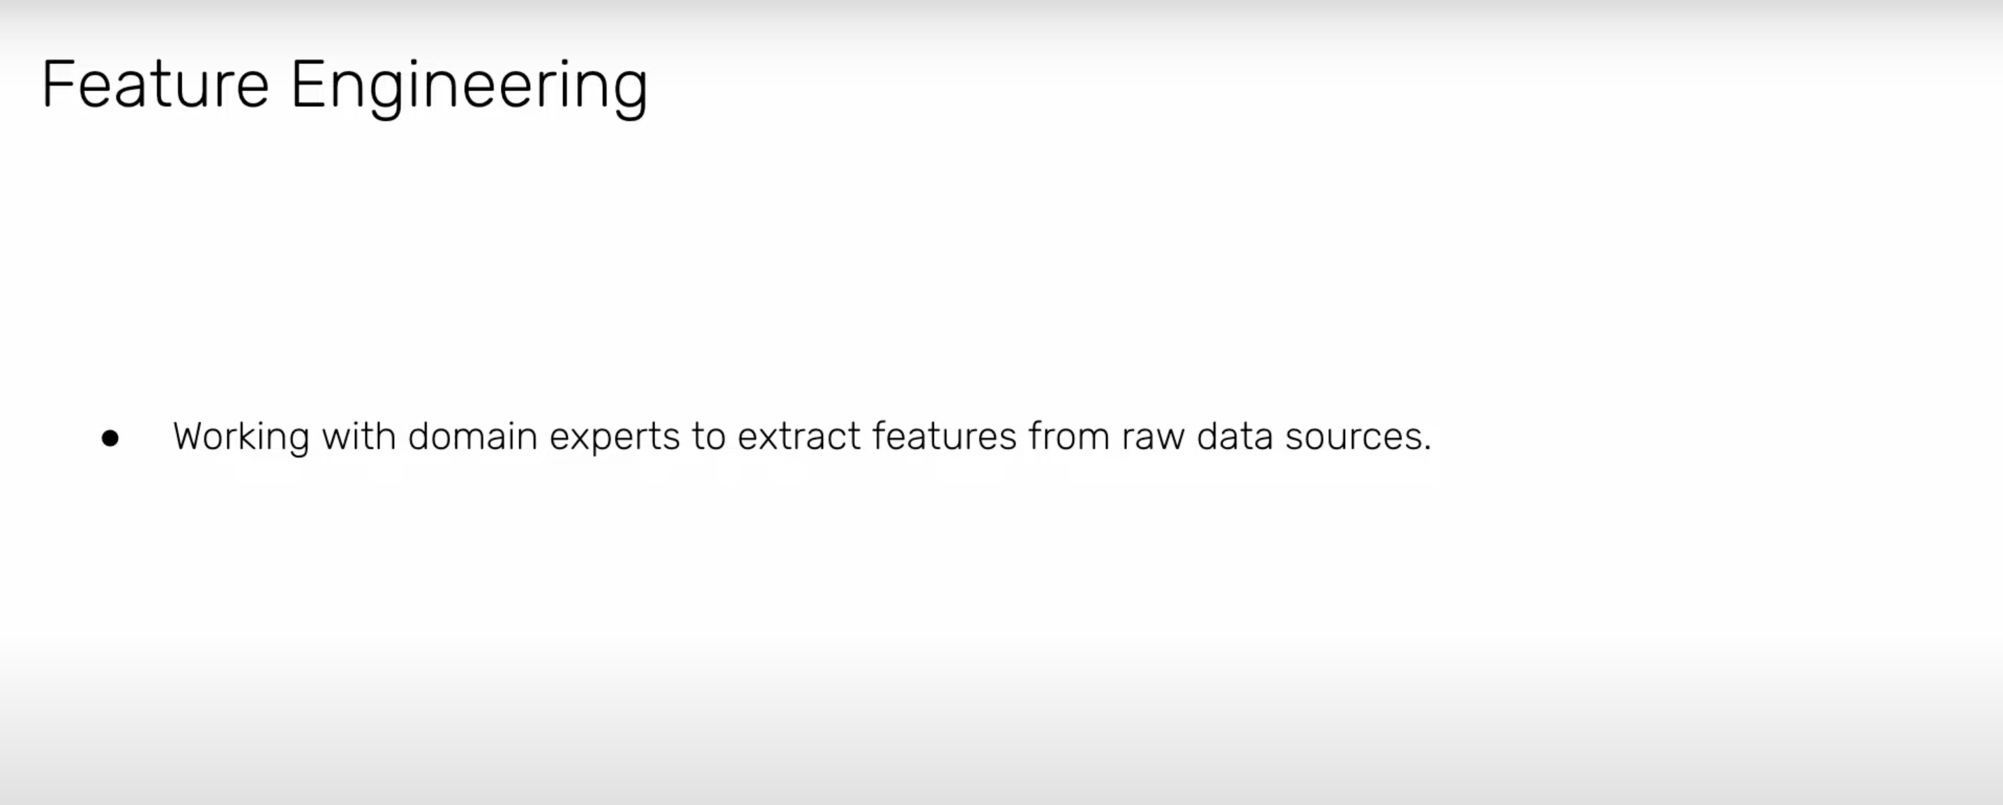

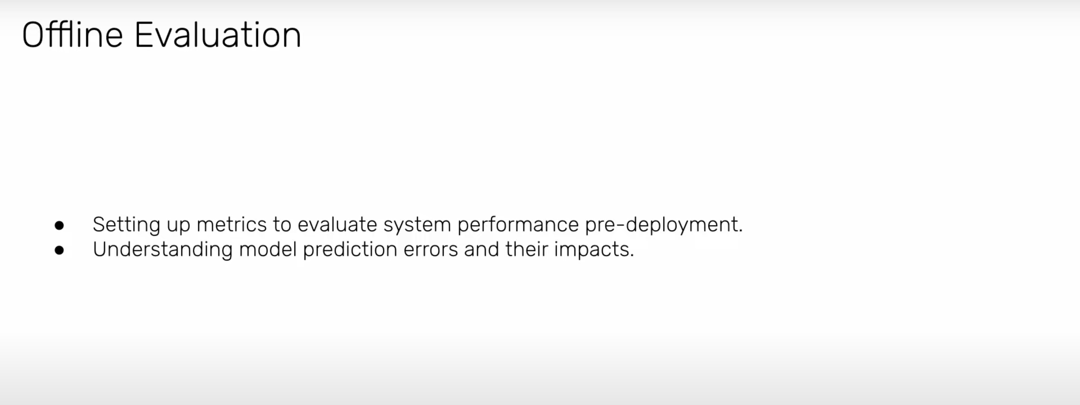

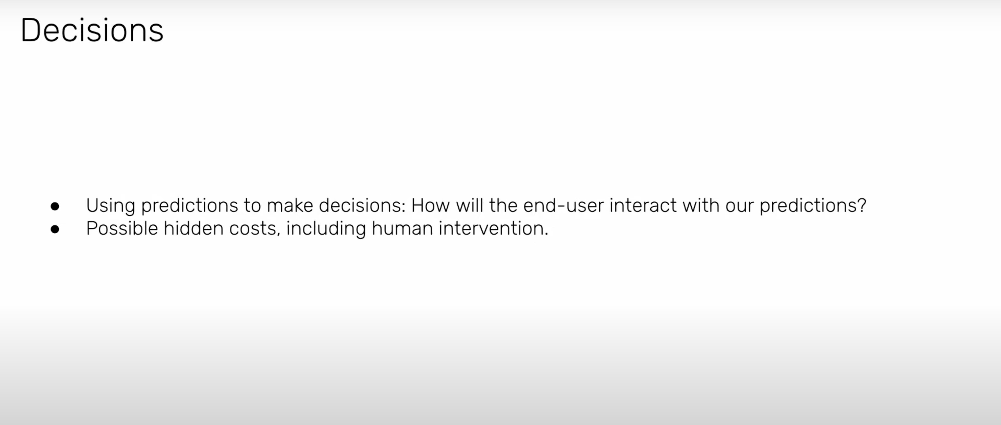

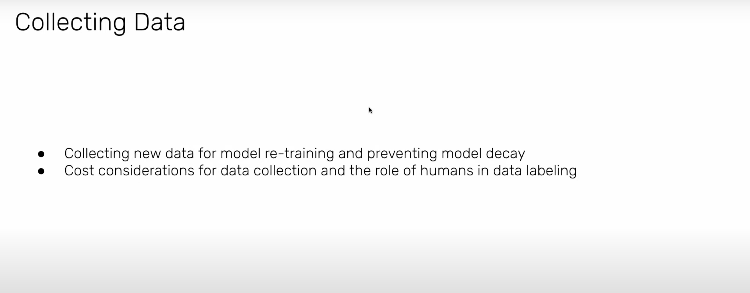

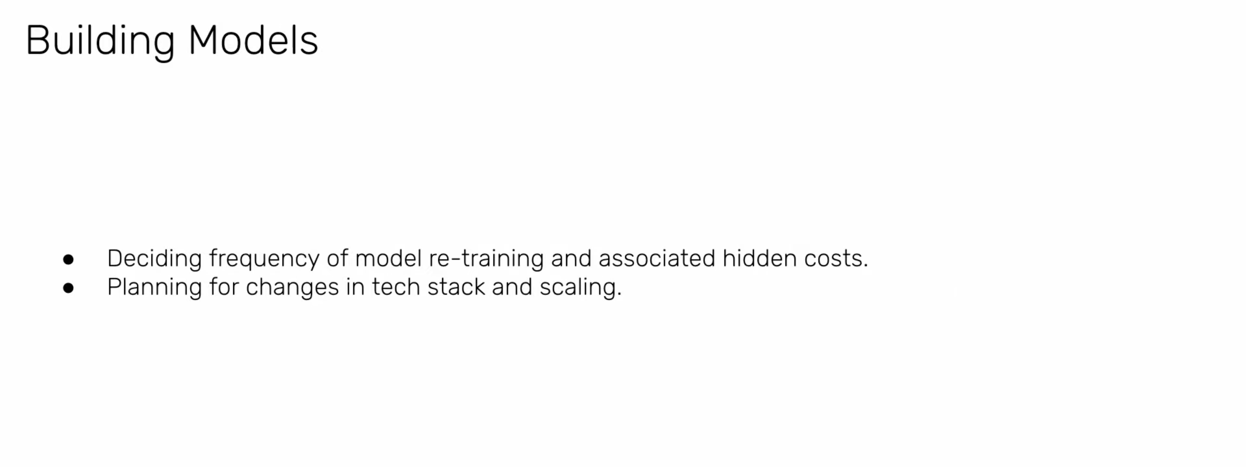

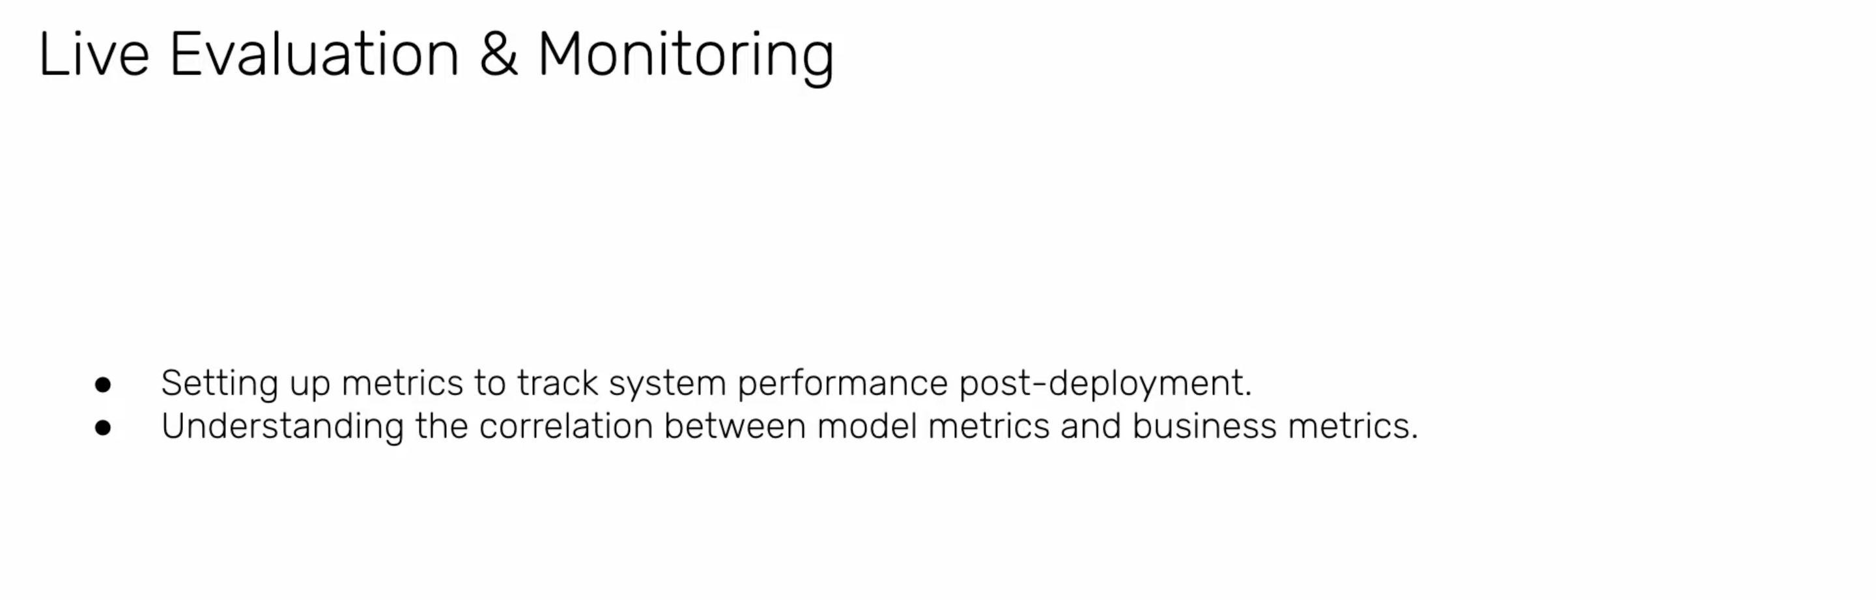

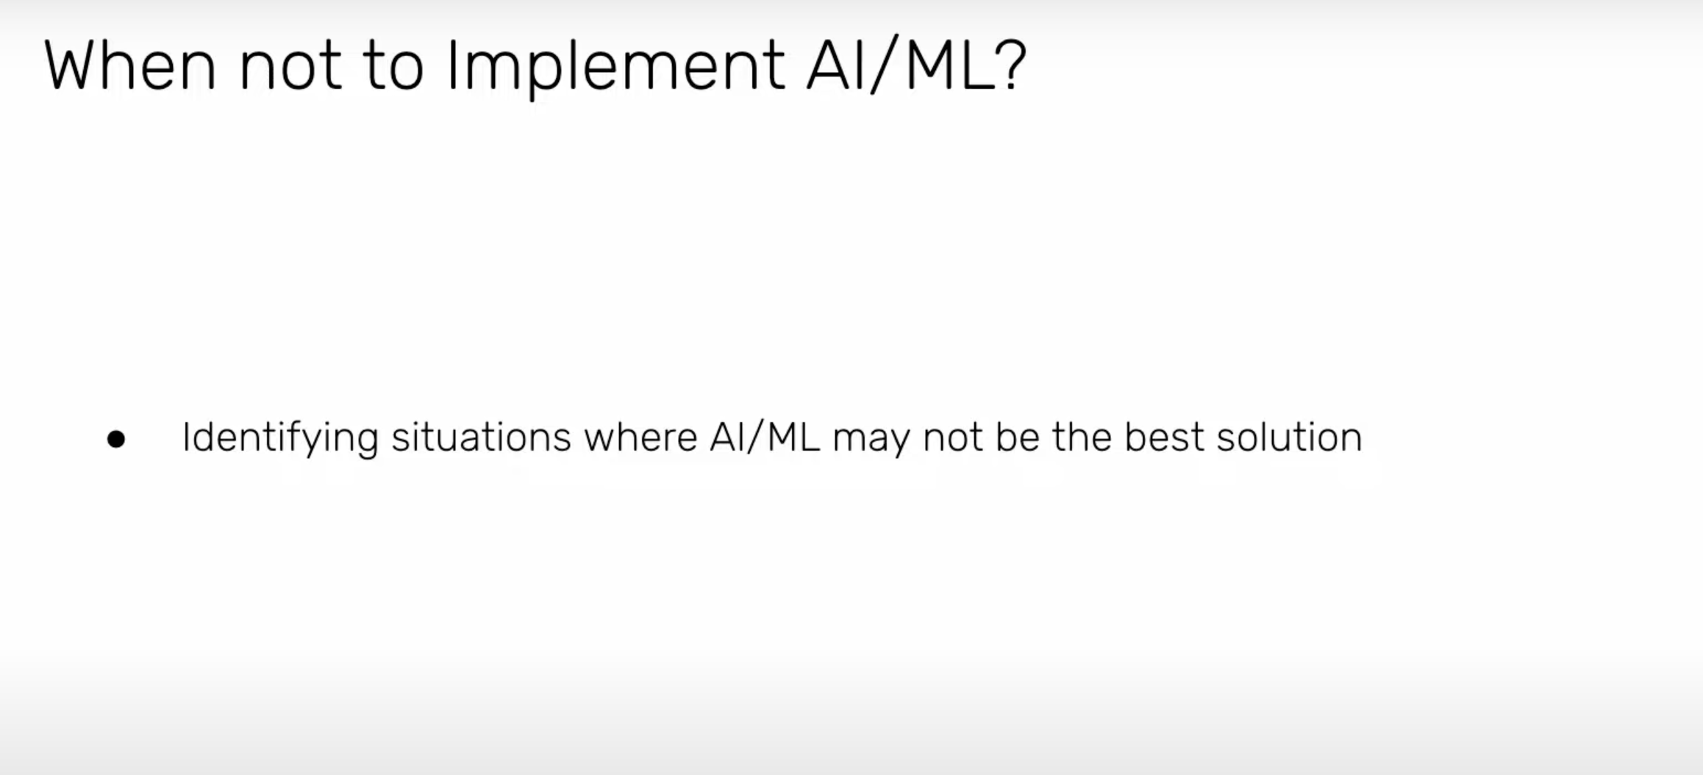

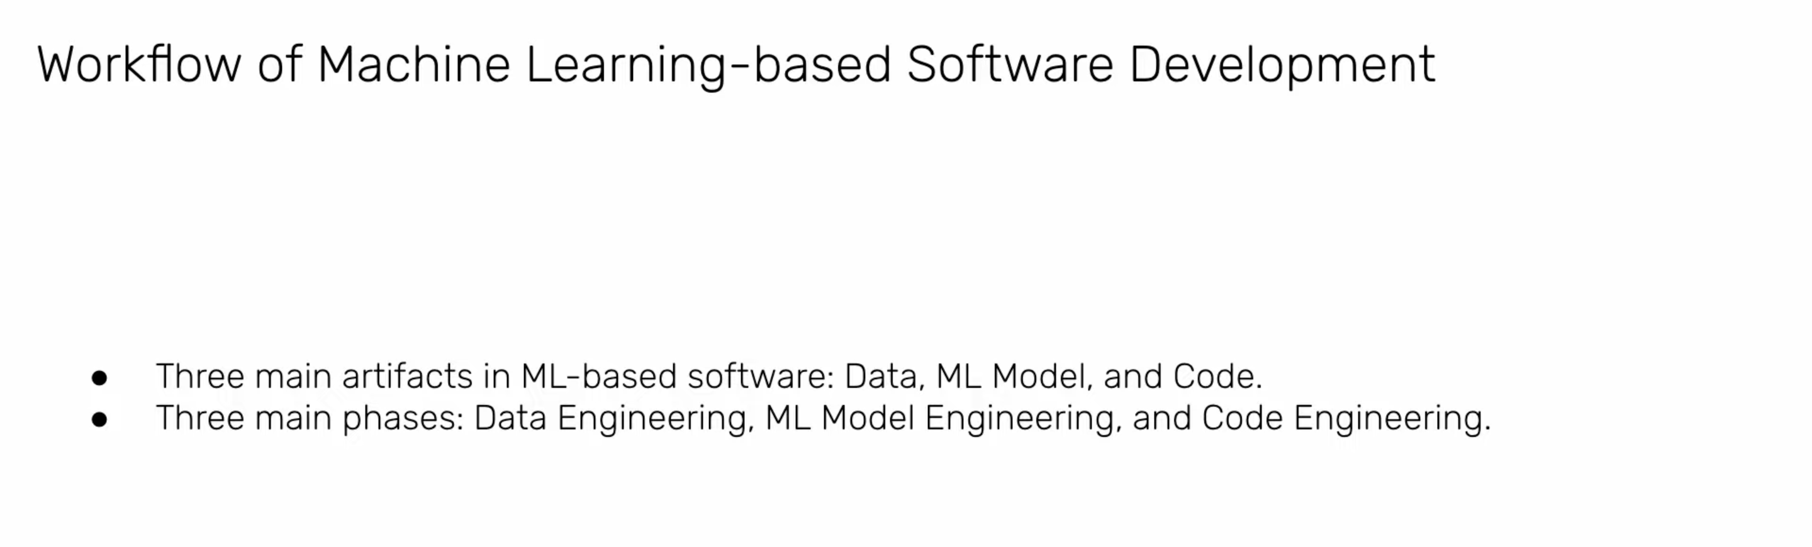

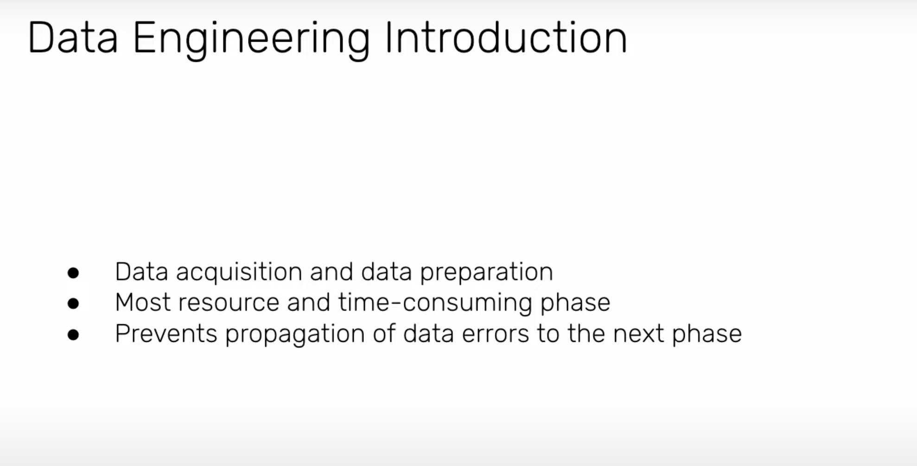

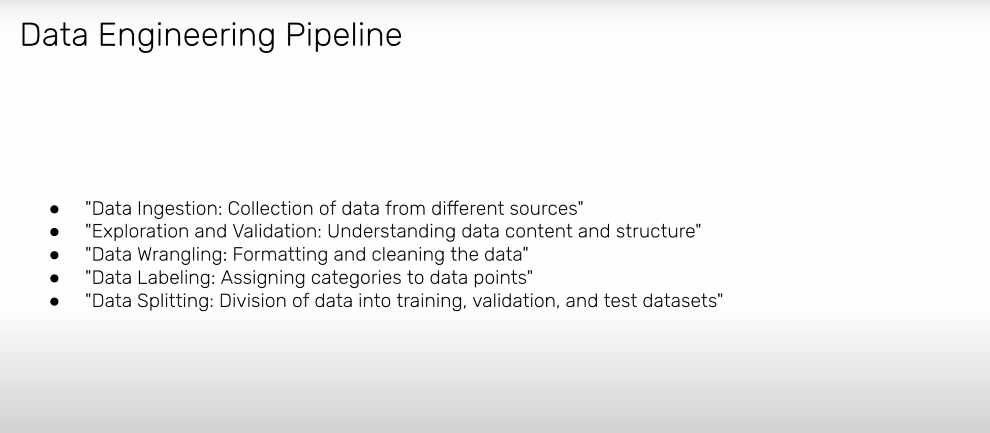

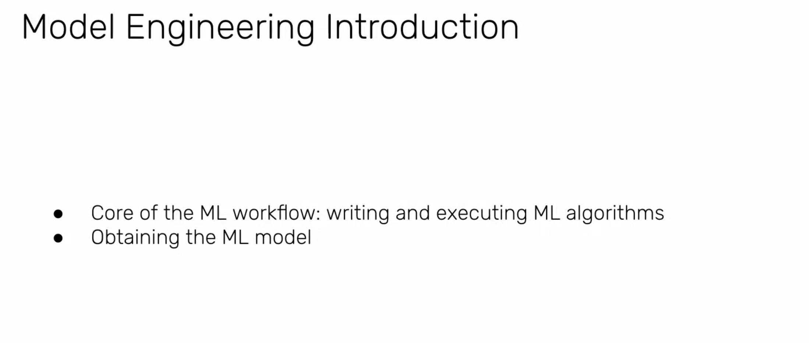

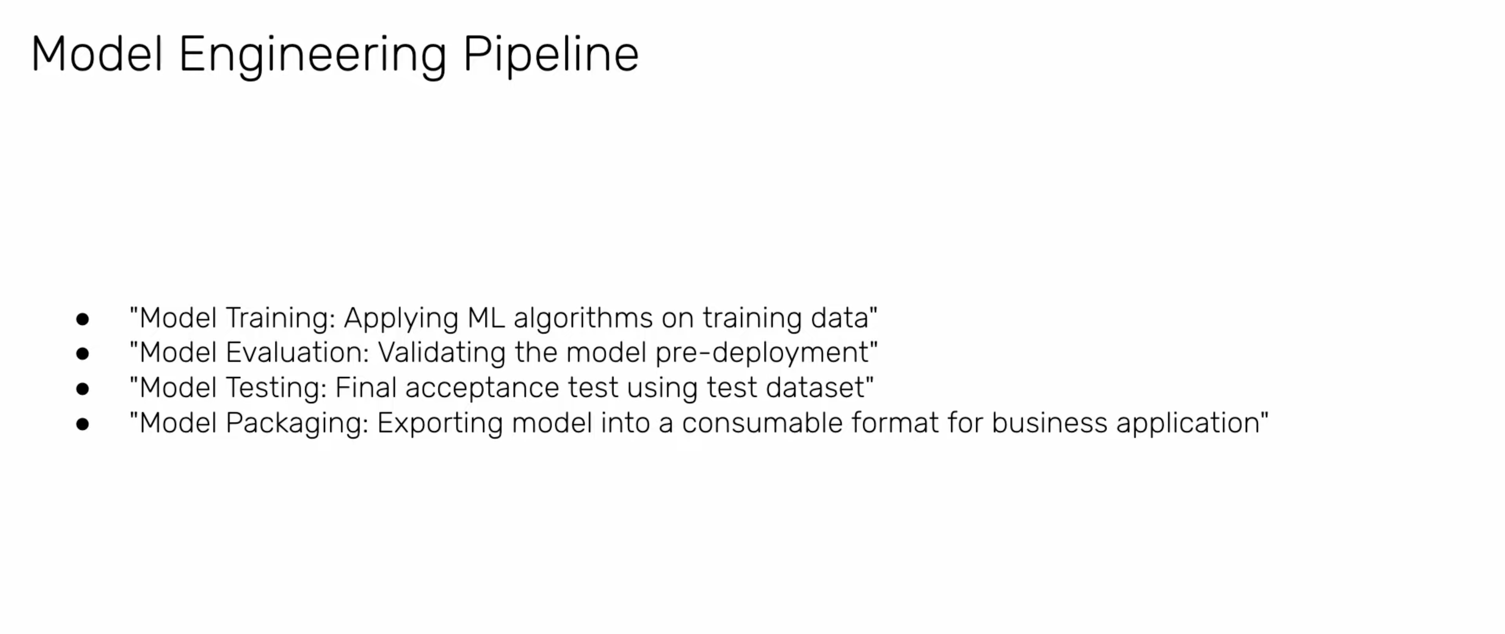

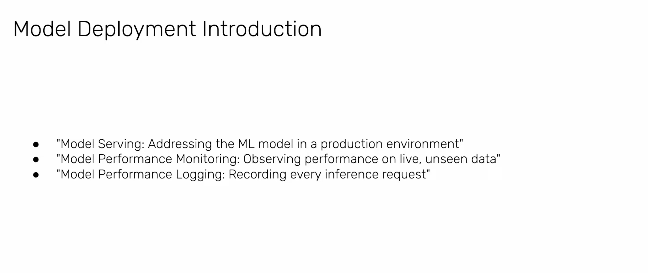

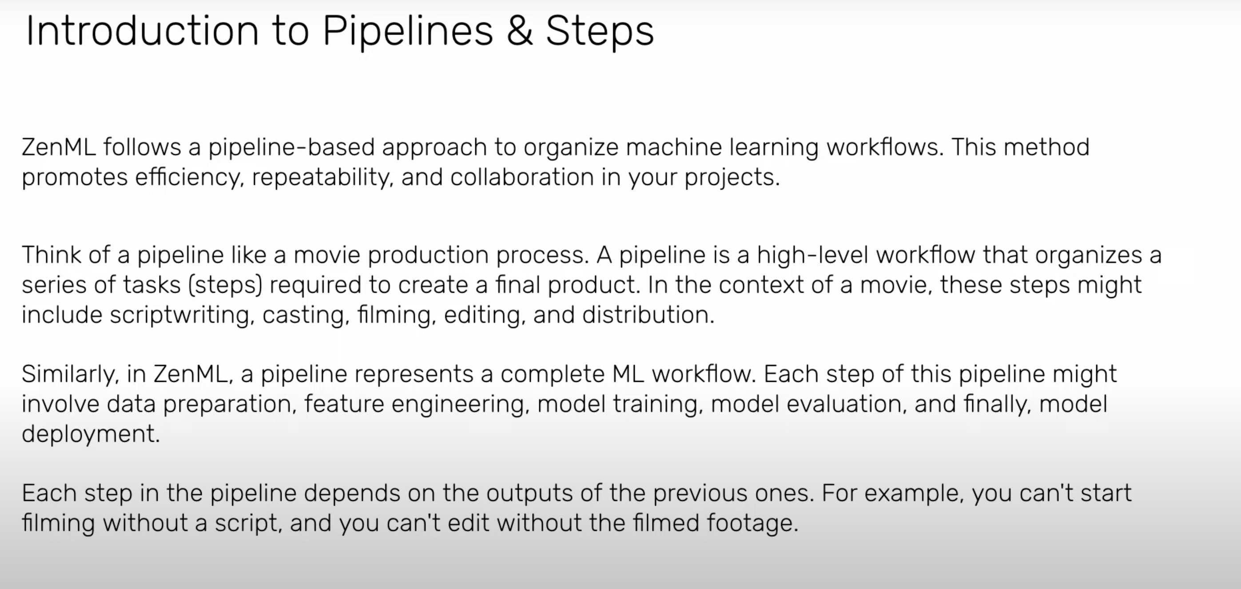

**Train Pipeline**

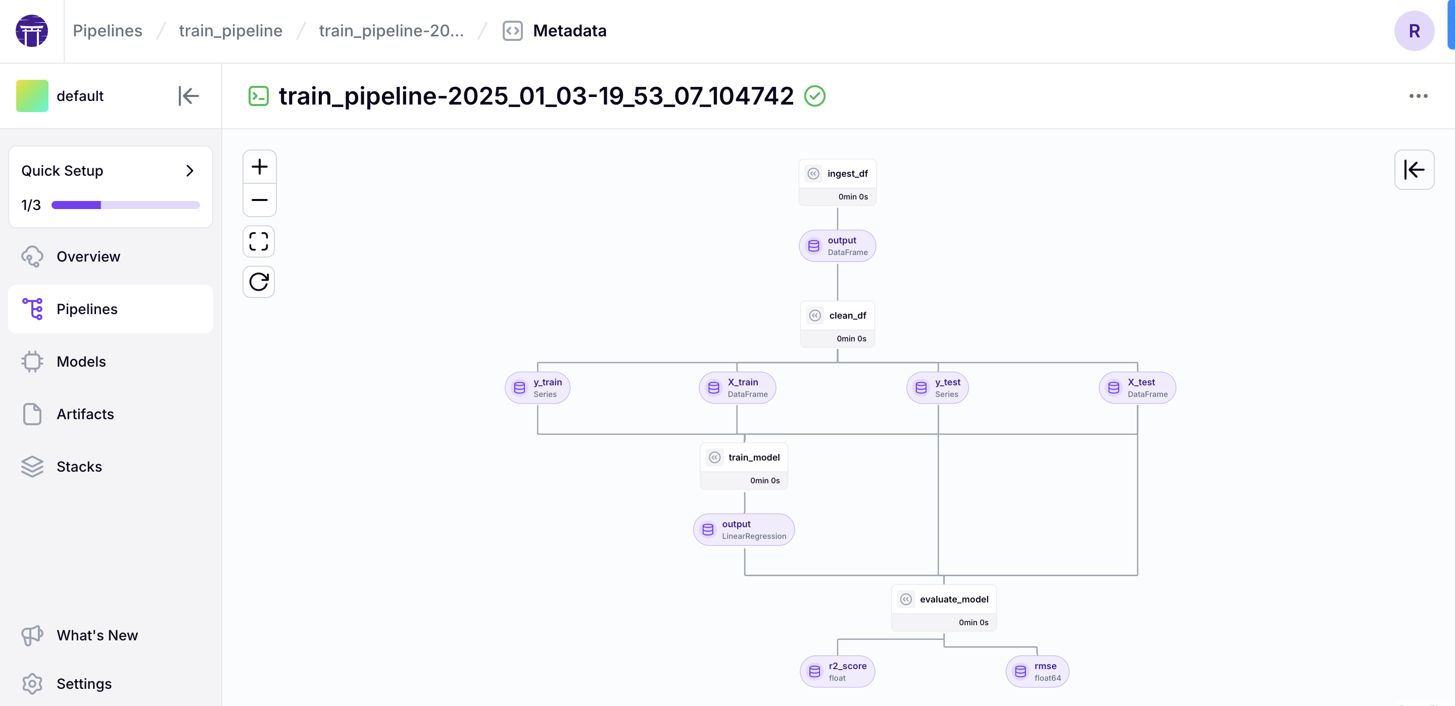

1. **Data Ingestion and Cleaning**:
   * The pipeline starts with an **ingest_df** step, which ingests the dataset and outputs a DataFrame.
   * The DataFrame is then passed to **clean_df**, where data cleaning and preprocessing occur.
2. **Data Splitting**:
   * The cleaned DataFrame is split into training and testing sets:
     + **X_train** and **y_train** for training features and labels.
     + **X_test** and **y_test** for testing features and labels.
3. **Model Training**:
   * **train_model** uses **X_train** and **y_train** to train a model, specifically a **LinearRegression** model, as indicated by the output type.
4. **Model Evaluation**:
   * The trained model is evaluated using **X_test** and **y_test** in the **evaluate_model** step.
   * Two evaluation metrics are calculated:
     + **r2_score** (float) – Evaluates the goodness of fit of the model,got a score of 0.0177 for our dataset
     + **rmse** (float64) – Measures the model's prediction error, got a score of 1.365312071798073 for our dataset

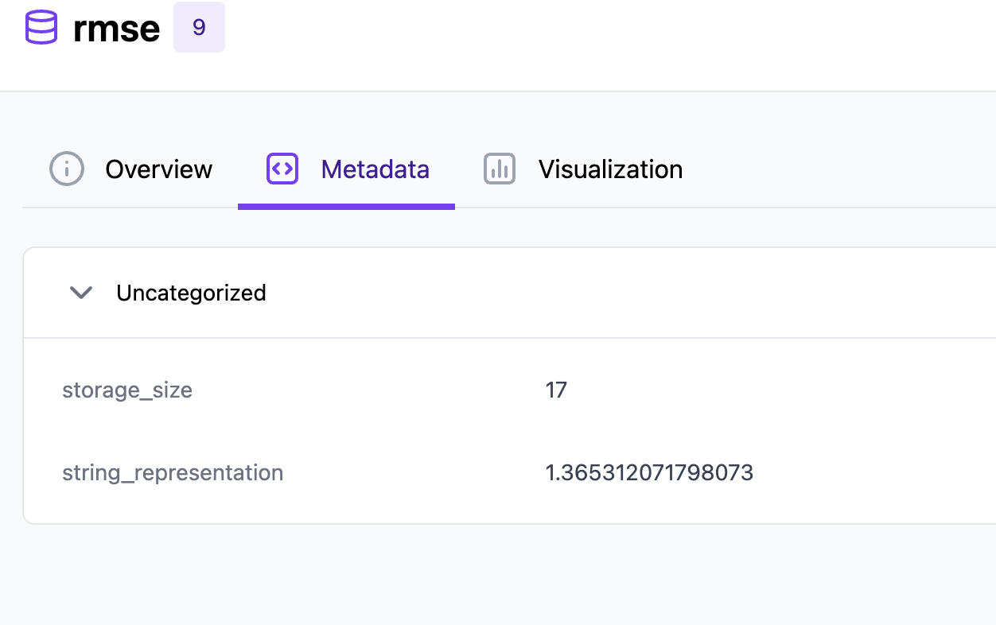

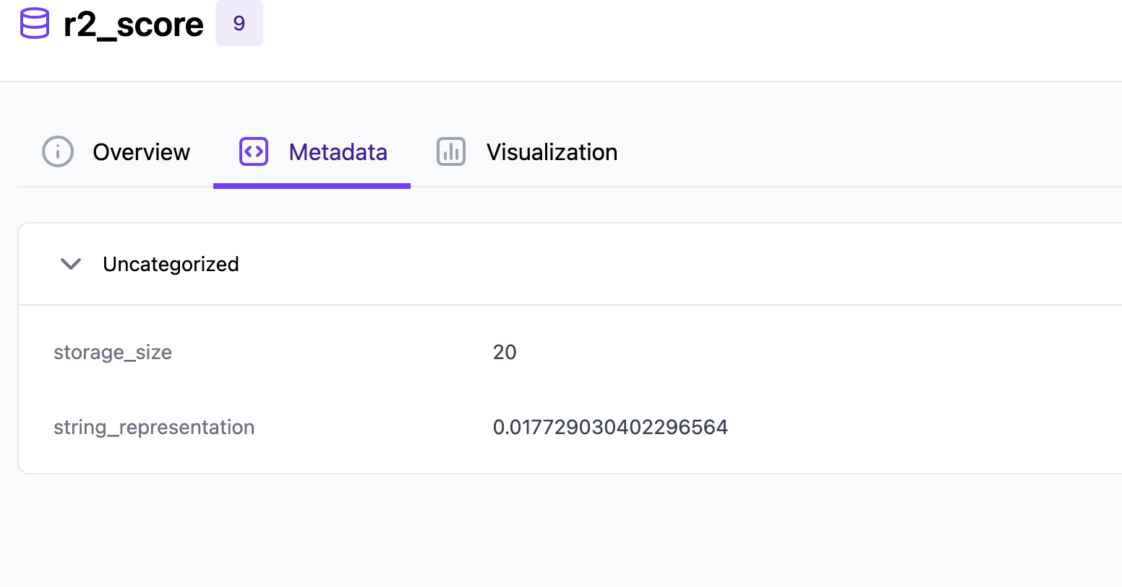

This pipeline follows a typical ML workflow: data ingestion, cleaning, splitting, training, and evaluation. It’s efficiently organized to ensure reproducibility and modularity in the ML process.

**Deployment Pipeline**

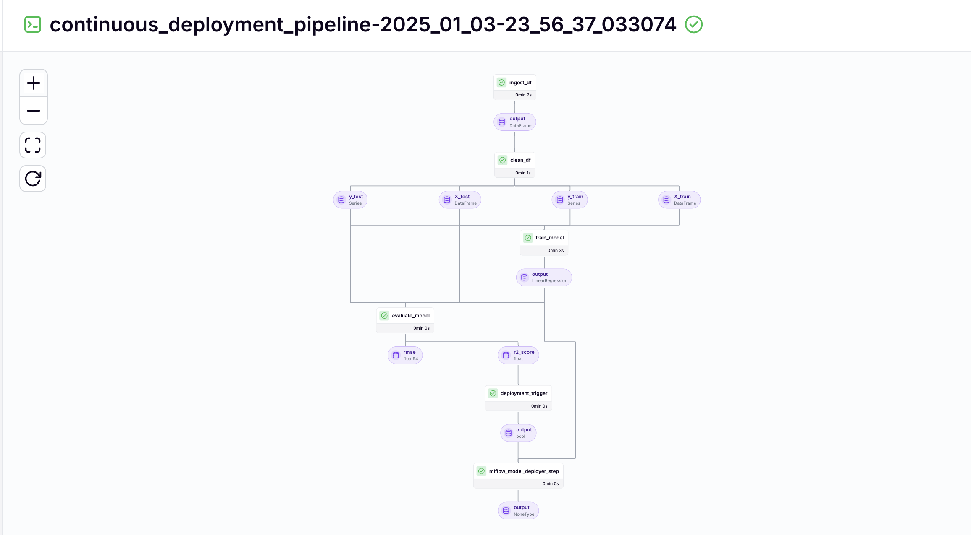

* **Deployment Trigger**:
  + **deployment_trigger**: Evaluates the model's performance and outputs a boolean value to decide if the model should be deployed.
* **Model Deployment**:
  + **mlflow_model_deployer_step**: If the deployment trigger condition is met, the model is deployed using **MLflow**, facilitating versioning and model management.